The Title of the Paper
First Author¹, Second Author^{2,3}, and Third Author³
¹ Institute1, City1, Country1
² Institute2, City2, Country2
³ Institute3, City3, Country3
vocal@p-graph.org
Abstract. This is the contents of the paper.
Keywords: First Keyword, Second Keyword, Third Keyword.
- First Section
  - Subsection of the First Section
First paragraph is not indented. First paragraph is not indented. First paragraph is not indented. First paragraph is not indented. First paragraph is not indented. First paragraph is not indented.
Other paragraphs are indented. Other paragraphs are indented. Other paragraphs are indented. Other paragraphs are indented.
Other paragraphs are indented. Other paragraphs are indented. Other paragraphs are indented.

Subsubsection is not numbered. This is the main part of subsubsection. This is the main part of subsubsection. This is the main part of subsubsection. This is the main part of subsubsection.
This is the main part of subsubsection. This is the main part of subsubsection. This is the main part of subsubsection.
Tables are centered as can be seen in Table 1.
Table 1. Table caption.
Heading | Heading | Heading
xxx | yyy | zzz
xxx | yyy | zzz
xxx | yyy | zzz
Equations are centered and set on a separate line.
x + y = z (1)
A figure example can be seen on Fig. 1.
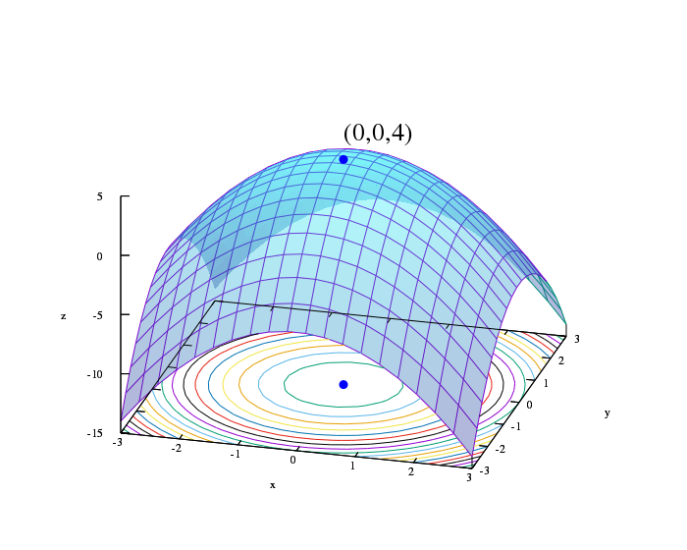
Fig. 1. Figure caption.
Citations of references signed with square brackets [1]. Some reference examples are in the References Section.

References
- Author, X.: Article title. Journal 1(2), 1–6 (2021).
- Author, Y., Author, Z.: Title of a proceedings paper. In: Editor, A., Editor, B. (eds.) Conference, vol. 123, pp. 1–10. Publisher (2010).
- VOCAL Homepage, http://vocal.p-graph.org, last accessed 2022/04/05.

